

Assignment By: Bhaumik Patel

Student ID: 200263830

|  |  |  |
| --- | --- | --- |
| **SR. NO.** | **CONTENT** | **PAGE** |
| 1 | Brief Description | 3 |
| 2 | Navigation Bar Section | 4 |
| 3 | Colour Section | 8 |
| 4 | Typography Section | 9 |
| 5 | Wireframe Section | 10 |
| 6 | Branding Section | 16 |

**BRIEF DESCRIPTION OF WEB SITE**

This is a simple web site created using HTML5, CSS3 and JS, it demonstrate simple designing ability that could possibly achieve by few knowledge of HTML and CSS, this is the responsive site created to demonstrate what type of work i am able to do in area of web development.

In this site there are few section which i use to display my past work on website and there are total 6 pages included in Navigation Bar which will be describe in further parts of this documentation I try to apply various JS and Extended function of CSS3 to demonstrate responsive site functionality I took an idea and adopt some technique from *“Responsee”* which is framework for HTML-CSS just like *“Foundation”*.

Different Pages of site illustrate Different area of functionalities, HOME page give functionality of slider, ABOUT ME page demonstrate text document and downloadable links on page, PROJECT and SERVICES pages gives idea about creating picture gallery, LOCATION page demonstrate use of maps on HTML page, CONTACT page give ability to demonstrate social media connectivity and active fully functional contact form which sends email on submitting the data.

**NAVIGATION BAR SECTION**

Navigation bar set at top section of page which looks like image below.



Clicking on “HOME” page will highlight the active page and redirect to the home page of web site which looks like image below. Which contain the slider basically demonstrating my past work samples.

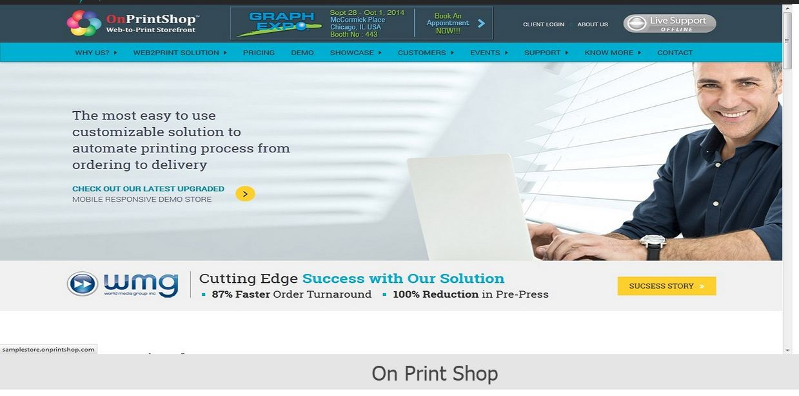

The second page is about me.



Which redirect to the page on which there is some description about myself and also containing the link to download my resume

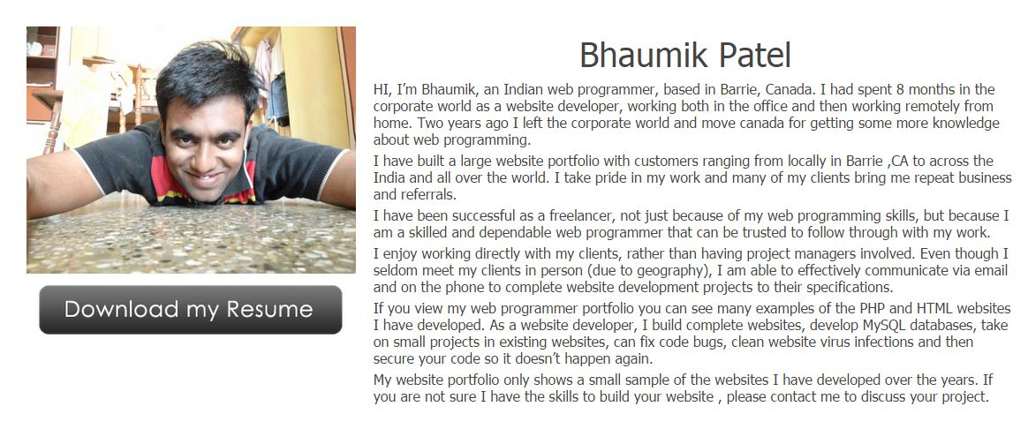

Link to Download my Resume

Third page contain a records of my projects.



Which redirect to the page containing the project works and that looks like below image.

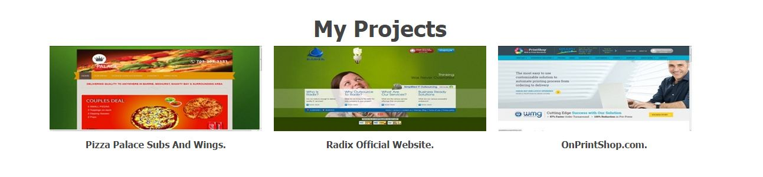

Fourth page is about services which are provided by company.

On clicking this page will redirect to the page where image and description will describe which services provided by our company. It looks like the image below.



Page 5 is about location which redirect to page where Google map is plotted to display my address.



That looks like image below.

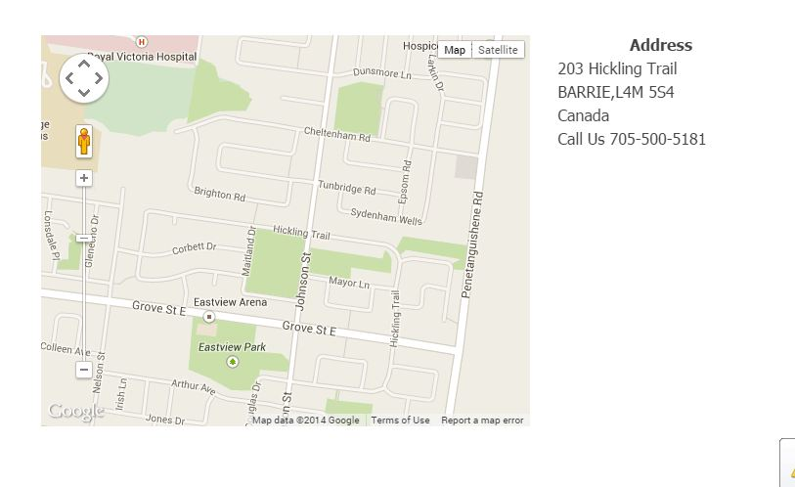

Last page is about contact form which allow guest user to fill form like name, email and massage, and also allow to upload file with the email.



That information will directly forward to my email address. And also include the link to social media which directly redirect to the social media website on company profile.

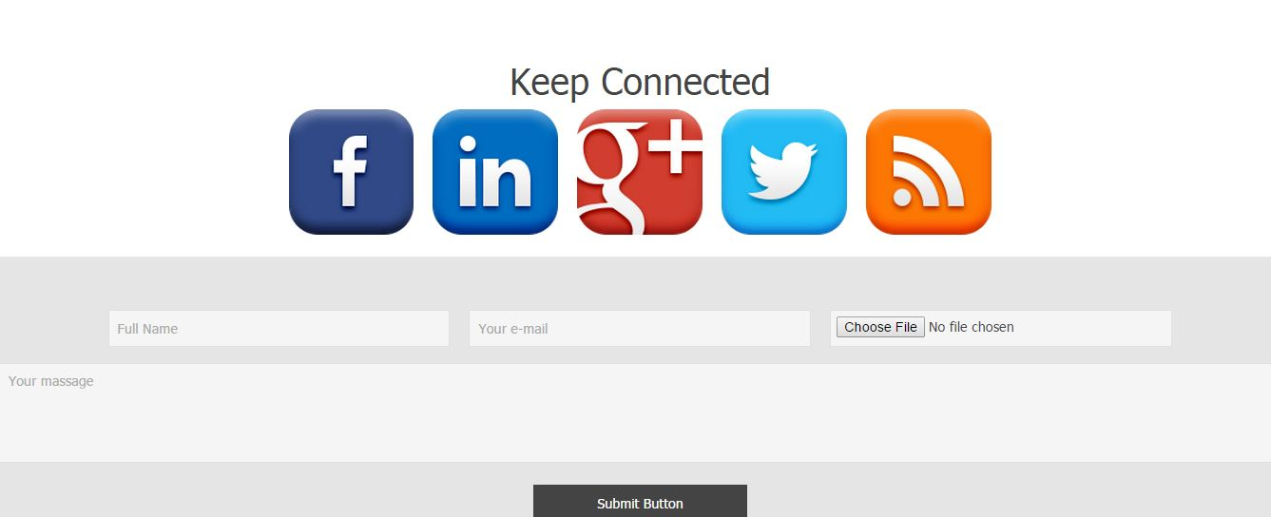

**COLOURS SECTION**

|  |  |
| --- | --- |
| **COLOR CODE AND SWATCHES** | **USE OF COLOR** |
| C:\Users\Jay Mata Di\Desktop\ASSIGNMENT1_DOC_SUP_IMG\c1.JPG | Background of navigation bar |
| C:\Users\Jay Mata Di\Desktop\ASSIGNMENT1_DOC_SUP_IMG\c2.JPG | Active page on navigation bar |
| C:\Users\Jay Mata Di\Desktop\ASSIGNMENT1_DOC_SUP_IMG\c3.JPG | Footer background |
| C:\Users\Jay Mata Di\Desktop\ASSIGNMENT1_DOC_SUP_IMG\c4.JPG | Navigation Links |
| C:\Users\Jay Mata Di\Desktop\ASSIGNMENT1_DOC_SUP_IMG\c5.JPG | Navigation Links Hover |
| C:\Users\Jay Mata Di\Desktop\ASSIGNMENT1_DOC_SUP_IMG\c7.JPG | Border colour |
| C:\Users\Jay Mata Di\Desktop\ASSIGNMENT1_DOC_SUP_IMG\c8.JPG | Navigation Visited links |
| C:\Users\Jay Mata Di\Desktop\ASSIGNMENT1_DOC_SUP_IMG\c9.JPG | Form Background |

**TYPOGRAPHY SECTION** 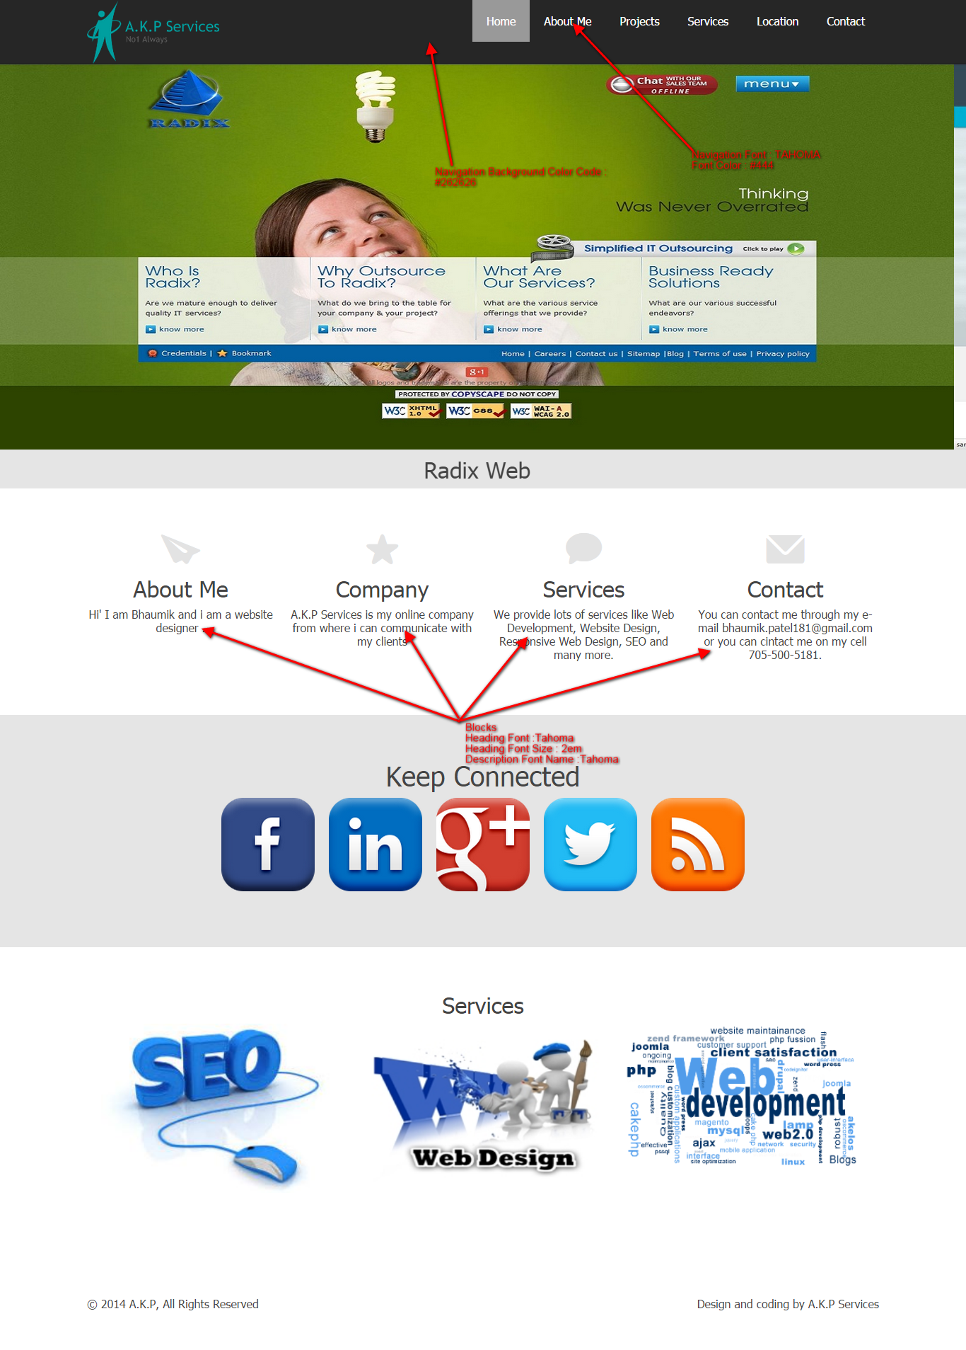

**WIREFRAMES SECTION**

HOME PAGE

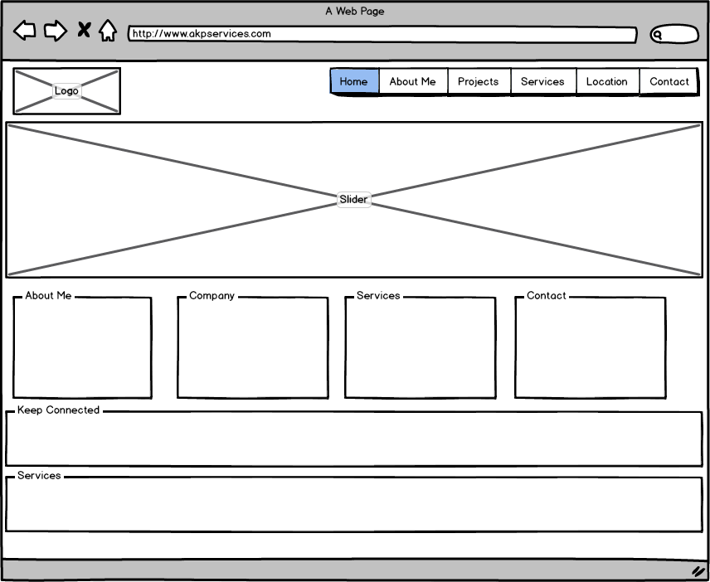

ABOUT ME

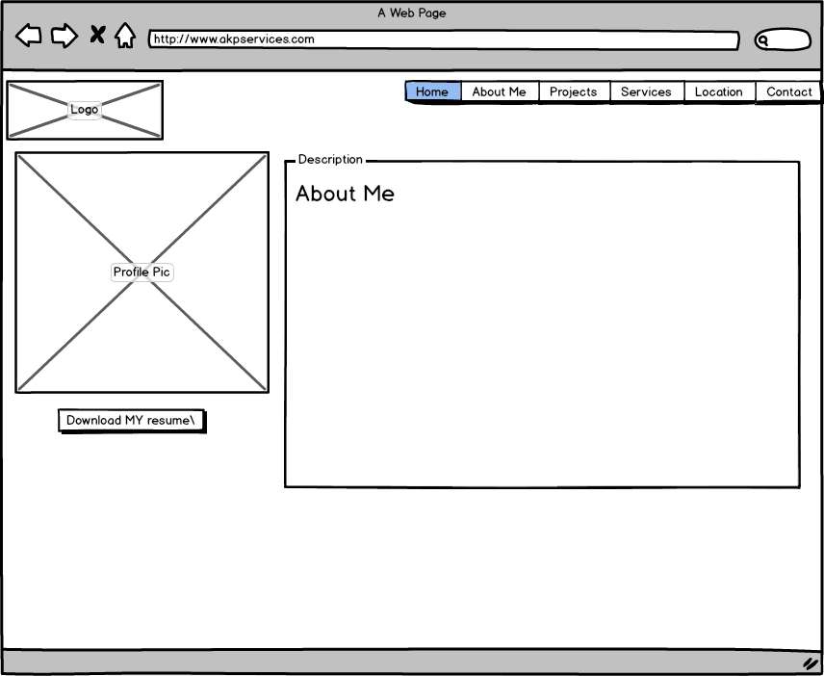

Projects

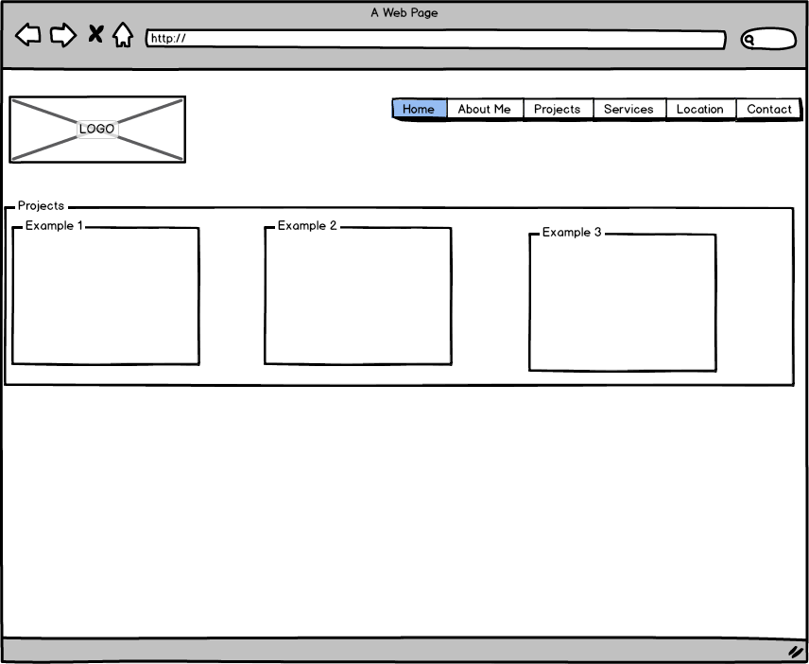

Services

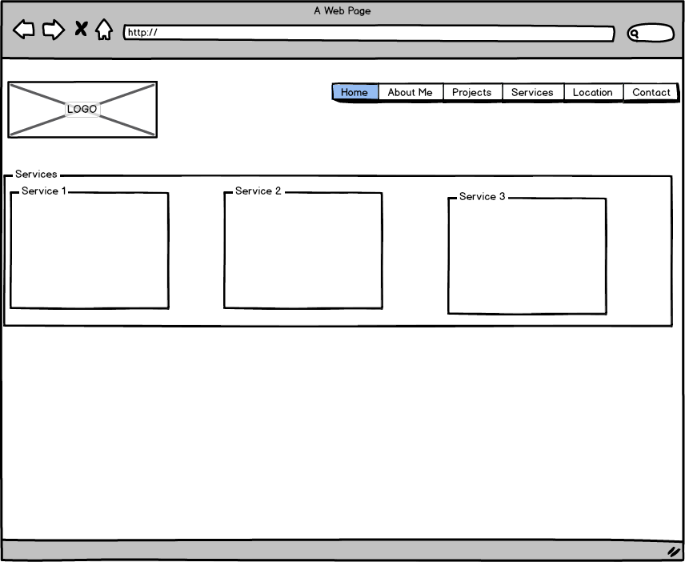

Location

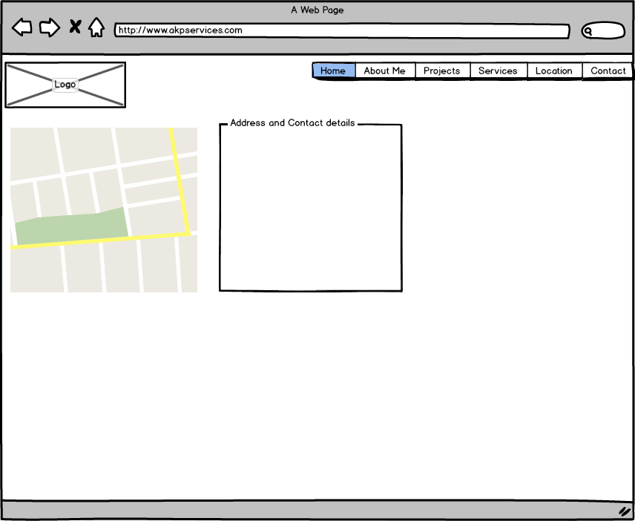

Contact

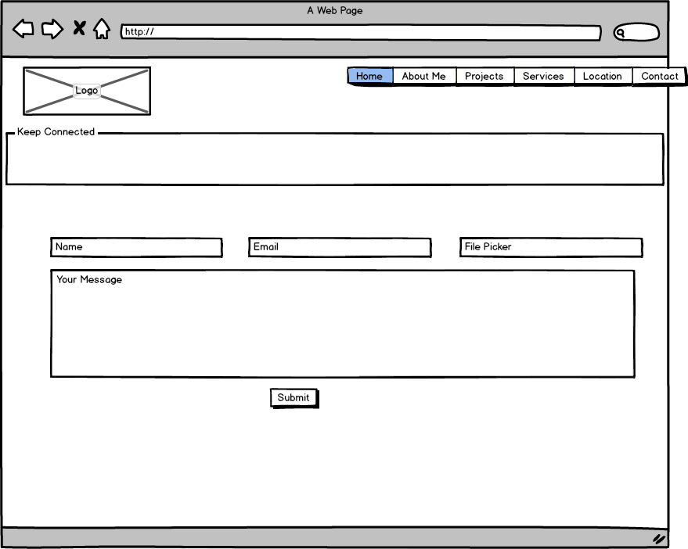

**BRANDING SECTION**

**Navigation bar Template:-**

****

**Home Page Slider:-**

****

**About Me page With Downloadable Link:**

****

**Project Page:-**

* Description of project with image(screenshots).

****

**Contact me page:-**

* Contact form with information input items, to allow guest enter name, message and email with attachment.
* Quick links to get connected with developer social media Pages.

****